God is For Us by CityAlight

[Intro]
|D / / /|G / / /|
|D / / /|G / / /|

[Verse 1]
D G D
We won't fear the battle, we won't fear the night
G D Bm A
We will walk the valley with You by our side
D G D
You will go before us, You will lead the way
G D Bm A
We have found a refuge, only You can save

[Chorus]
D G D
Sing with joy now: our God is for us
G D Bm A
The Father's love is a strong and mighty fortress
D G D
Raise your voice now, no love is greater
G D A
Who can stand against us if our God is for us

[Intro]
|D / / /|G / / /|

[Verse 2]
D G D
Even when I stumble, even when I fall
G D Bm A
Even when I turn back, still Your love is sure
D G D
You will not abandon, You will not forsake
G D Bm A
You will cheer me onward with never-ending grace

CHORUS

[Intro]
|D / / /|G / / /|
|D / / /|G / / /|

[Bridge]
G A
Neither height nor depth can separate us
Bm D/F#
Hell and death will not defeat us
G A
He who gave His son to free us
Bm A
Holds me in His love
G A
Neither height nor depth can separate us
Bm D/F#
Hell and death will not defeat us
G A
He who gave His son to free us
Bm A
Holds me in His love

CHORUS X2

[Outro]
|D / / /|G / / /|
|D / / /|G / / /|

[End]
D

Intro:
F# F# D G G G
F# F# D G G G

Risen (Key: D, Time: 6/8)

Intro
D | G | D/A | A |

Verse 1
D A/D Bm G
Jesus, Jesus of Nazareth
D A/D Bm G (split bar)
Delivered up
D A/D Bm G
Crucified at the hands of the lawless
D A/D Bm G
But safe in the plan of God

Pre
Em G
The holy one has not seen decay
Em D C G
The grip of the grave could not contain him

Verse 2
D A/D Bm G
Servant, Holy and Righteous One
D A/D Bm G
Author of life
D A/D Bm G
Glorified by the God the fathers
D A/D Bm G
But by men denied

Pre
Em G
The promised one has suffered and died
Em D C G A
The gift of forgiveness has arrived

Chorus
D G A
Christ is risen and reigning
Bm G A
The gospel is spreading and saving
D G A Bm
The Spirit is poured out and giving new life
A G A
to us
D G A
Go and tell of the wonders of
Bm G A
God who is calling and claiming
D G A
His message is sent out and reaching the
Bm A G A
world through us

Interlude
D | G | D/A | A |

Verse 3
D A/D Bm G
Lord of all, Jesus the Son of God
D A/D Bm G
Good news of peace
D A/D Bm G
Nailed to a tree, now we have witnessed him
D A/D Bm G
Raised up and free

Pre
Em G
Anointed with the Spirit and power
Em D A
Appointed to be judge of all the world
Em G
He's the one the prophets spoke about
Em D C G A
Keeping every promise, every word

CHORUS

Epilogue
D G A Bm
We will be your witnesses
Bm G A D
We will testify to the end
D G A Bm
We will revel in the shame
Bm G A D
As we suffer for your name
D G A Bm
You will finish what you start
Bm G A D
You will open rebel hearts
D G A Bm
You're the one they crucified
Bm A G Em D
But God has made you Lord and Christ

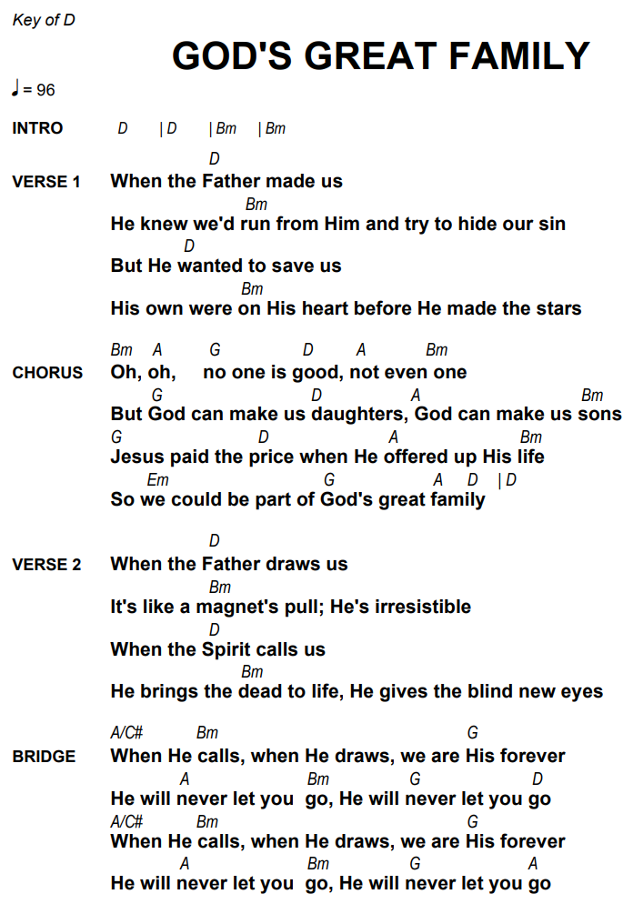
Ancient Word
[Intro]
G D Am C
D Em D G
C D G (These are Chorus chords)

[Verse]
G D G G C
Holy words long preserved, For our walk in
D
this world
Em D G G
They resound with God’s own heart, O let
C D G C G
the ancient words im--part
G D G
Words of life, Words of hope, Give us
C D
strength, Help us cope
Em D G G
In this world where e’er we roam, Ancient
C D G
words will guide us home

[Chorus]
G D Am
Ancient words ever true, Changing me and
C
changing you
D Em D G G
We have come with open hearts, O let the
C D G C G
ancient words im--part

[Interlude]
Em D G C D G C G (We have come…)

[Verse]
G D G G C
Holy words of our faith, Handed down to this
D
age

Em D G G
Came to us through sacrifice, O heed the
C D G C G
faithful words of Christ
G D G G C
Holy words long preserved, For our walk in
D
this world
Em D G G
They resound with God’s own heart, O let
C D G
the ancient words im--part

CHORUS

Closing: O Church Arise
Intro/Interlude: C Bb F G#
[Verse 1]
G7sus C F/A G
O church, arise and put your armor on;
C F Gsus C
Hear the call of Christ our captain;
G7sus C F/A G
For now the weak can say that they are strong
C F Gsus C
In the strength that God has given.
F C G
With shield of faith and belt of truth
C F C Am G
We'll stand against the devil's lies;
G7sus C F/A G
An army bold whose battle cry is "Love!"
C F Gsus C
Reaching out to those in darkness.
Interlude
[Verse 2]
G7sus C F/A G
Our call to war, to love the captive soul,
C F Gsus C
But to rage against the captor;
G7sus C F/A G
And with the sword that makes the wounded whole
C F Gsus C
We will fight with faith and valor.
F C G
When faced with trials on ev'ry side,
C F C Am G
We know the outcome is secure,
G7sus C F/A G
And Christ will have the prize for which He died—
C F Gsus C
An inheritance of nations.

[Chorus]
G F C
Arise, shine for Your light has come
G F C
Arise shine for the Risen Son
Am G F C
Lift Your eyes, we are His radient bride
Dm G C
Arise O Church arise

INTERLUDE
[Verse 3]
G7sus C F/A G
Come, see the cross where love and mercy meet,
C F Gsus C
As the Son of God is stricken;
G7sus C F/A G
Then see His foes lie crushed beneath His feet,
C F Gsus C
For the Conqueror has risen!
F C G
And as the stone is rolled away,
C F C Am G
And Christ emerges from the grave,
G7sus C F/A G
This vict'ry march continues till the day
C F Gsus C
Ev'ry eye and heart shall see Him.

[Chorus]
G F C
Arise, shine for Your light has come
G F C
Arise shine for the Risen Son
Am G F C
Lift Your eyes, we are His radient bride
Dm G C
Arise O Church arise
INTERLUDE
[Verse 4]
G7sus C F/A G
So Spirit, come, put strength in ev'ry stride,
C F Gsus C
Give grace for ev'ry hurdle,
G7sus C F/A G
That we may run with faith to win the prize
C F Gsus C
Of a servant good and faithful.
F C G
As saints of old still line the way,
C F C Am G
Retelling triumphs of His grace,
G7sus C F/A G
We hear their calls and hunger for the day
C F Gsus C
When with Christ we stand in glory

CHORUS X2
INTERLUDE X2

